

Student Guide

A quick-start reference to Sonia Online for students

setting the standard for student placement software

Copyright
Copyright © 2017, Planet Software Pty Ltd. Licensed users of Sonia are permitted to copy and reprint all or part of this document for the purposes of supporting their use of Sonia.

Sonia is a registered trademark of Planet Software Pty Ltd.

Disclaimers
This document is provided at no charge to licensed users of Sonia. The information it contains is provided without any express, statutory or implied warranties. Planet Software Pty Ltd will not be held liable for any damages caused or alleged to be caused either directly or indirectly by this document.

This document has been edited for use by Oakland University students enrolled in the Criminal Justice program’s internship course (CRJ 4950). None of the changes to the original document have been approved by Planet Software Pty Ltd.

The example data depicted herein as text and images are based on the “impersonation” of a student by a professor (Dr. Jacob Becker). No association with any real student enrolled at Oakland University should be inferred.

Contents
Student Guide 1
A quick-start reference to Sonia Online for students 1
Copyright 2
Disclaimers 2
Introduction 4
- Starting Sonia 4
  - Signing In 4
  - Sonia Online 4
- Navigating Sonia 5
  - Home Tab 6
  - Internships Tab 6
  - Forms Tab 7
  - My Details Tab 8
  - Checks Tab 8
  - History Tab 9
  - Calendar Tab 9
Conclusion 10

Introduction
This guide is provided to Oakland University Criminal Justice students who are using Sonia as part of their internship course (CRJ 4950) to assist in the administration of field work placements (i.e. internships).

Starting Sonia
To access Sonia, you will need a web (internet) browser and internet access. For optimal performance, we suggest Chrome, Firefox, or Edge.

Signing In
An account has been created for you that uses your Oakland University “single sign-on” (SSO) credentials. First, go to the main Sonia webpage for the OU CRJ program at oaklandcrj.sonialive.com. We recommend that you bookmark this page for the duration of your enrollment in CRJ 4950 for easy use. When you first reach this webpage, you should see a screen like this:
Ensure the ‘Role’ is set to ‘Student’ and click ‘University Sign In.’ You will be redirected to sign in using your normal OU NetID and password. Once your credentials are validated (including two-factor authentication if applicable), you will return to Sonia Online.

Sonia Online
You should now see the screen below:
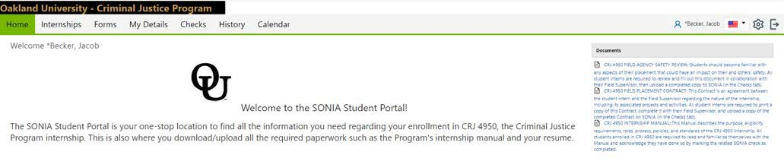
This is the customized Home screen for the OU Criminal Justice program Sonia Online website, and where you will always begin after logging in. There are several elements on this page to note. Below the Oakland University – Criminal Justice Program header, you should see a series of tabs, e.g. ‘Home,’ ‘Internships,’ and so on. We’ll explore these in more depth later, as each tab includes different content and information in the main part of the screen. In this case, for example, the ‘Home’ tab welcomes you by name and includes a welcome message from the CRJ program. There are also several downloadable documents located to the right which you will need to download and complete at some point in the CRJ 4950 process.

In in the upper right corner there are several buttons which are always visible, no matter which tab you are currently on:
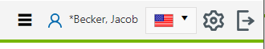
1
2
3

    - If you see three horizontal lines next to your name, this means that your screen is not wide enough to display all of the tabs. Click this symbol to see additional menu items (or make your screen wider to display all of the tabs).
    - Clicking the cog symbol will take you to your Account Settings page. Here is where you can:
      - Select a culture in which to view Sonia Online (this changes the language of Sonia Online, among other things; however, all forms, documents, etc. used by the CRJ program will remain in English).
      - Opt to take advantage of the accessibility features if you use a screen reader. To do this, click the “enhanced accessibility” box.
      - Change/upload a picture of yourself.
      - Download the Sonia for Students mobile app; follow the instructions here for how to get it on your mobile device.
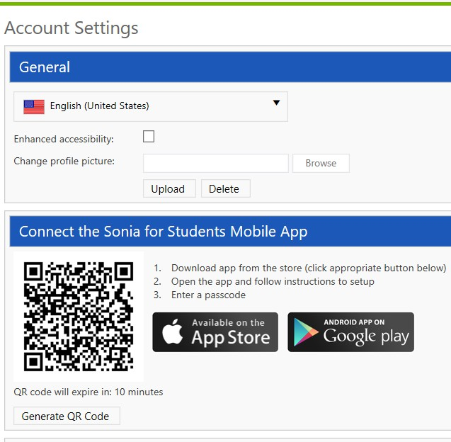

    - Sign out of Sonia Online by clicking the exit door on the far right side of the screen.

Navigating Sonia
It’s easy to get overwhelmed with the all of the possible functions of Sonia, as well as a new and unfamiliar web interface. We have done everything we can to simplify the website as much as possible, so that almost everything you see on Sonia has a specific purpose within the internship experience. (There are a few exceptions where it was not possible to remove certain tabs or functions that you are unlikely to ever use or need). The most important thing for you

to be familiar with are the various tabs, as each contains a particular type of information or process that you’ll need to successfully complete CRJ 4950.

Home Tab
We have already covered the ‘Home’ tab. This is where you begin after logging into Sonia Online. There is not much content on this tab, except for the documents located to the right of the screen. Each document will be important at a particular stage of the internship placement process; for example, you are required to download and review the Internship Manual prior to placement. You will receive instructions via email over the course of CRJ 4950 telling you exactly when and how you need to access and use these documents.

Internships Tab
The “Internships’ tab contains important information about your placement group – this is another term for your cohort of CRJ 4950 students. We use the placement group to keep track of students who share something in common (like being currently enrolled in CRJ 4950). You can use this tab to keep track of where you are in the placement process and any outstanding tasks you have to complete, as well as find more detail information on your internship (once you’ve been placed in a particular site).
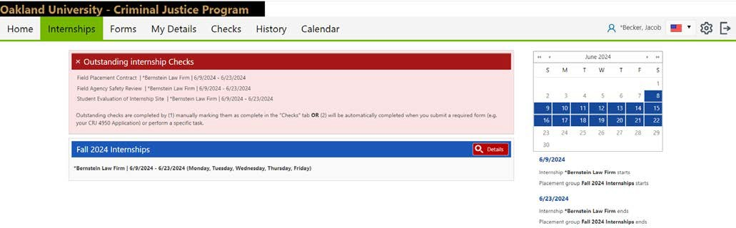
1
2
4
3

There are four elements in this tab:

    - A “check” is Sonia vocabulary for required tasks; in this tab, the “Outstanding Checks” box lists activities that you must complete in order to satisfy the requirements of the CRJ 4950 course. As described later, these checks are organized into those you finish either before or after being placed in an internship. In this example, the student has already completed all their pre-placement checks and been placed in an internship at the Bernstein Law Firm. They must now complete three tasks that are specific to their placement/site and field supervisor: fill out and upload a field placement contract, an agency safety review, and (nearer the end of the internship) a site evaluation. These checks will either be automatically completed (like if the student fills out and submits a form on Sonia) or will be manually updated by the student in the ‘Checks’ tab as instructed in an email. Students who do not have any checks currently outstanding will not see this red box at all. Checks will be discussed in more depth a bit later in this document.
    - The blue box lists the internship site (the agency, company, etc.) where you have been placed. If you have not yet been placed this box will not be shown or be blank. The title

of this box is your placement group (here, the Fall 2024 cohort of students enrolled in CRJ 4950). Below you will see the name and a few details of the placement. This student has been placed at Bernstein Law Firm for the period between June 9th and June 23rd and is expected to be working Monday through Friday.¹
    - The red “Details” button at the top right of the blue placement group box is not used by the CRJ program. If you decide to explore this feature, it will take you to a page with additional information about your site and placement, though this is available elsewhere on Sonia Online.
    - Like the “Details” button, the monthly calendar on the right side of this tab is not particularly useful for us in the Criminal Justice program, and can be safely ignored.

Forms Tab
This tab lists forms that you have to complete online in Sonia to meet the requirements of CRJ 4950. Two forms will be assigned to you during your internship process: a CRJ 4950 application and an evaluation of your internship site. You will be notified by email when a form is assigned to you. Submitting a completed form automatically satisfies a required check for CRJ 4950, as discussed earlier. Completing forms is a simple process:

    - Once a form is assigned to you, the name of the form will be displayed in the blue horizontal bar, with some additional information in the box below it.
    - Clicking the red “Edit” button at the right of the blue title bar will open the form in a new browser window.
    - Complete the form, being careful to follow any instructions provided and making sure you don’t accidentally skip any required information. NOTE: some of the fields will be automatically filled in, like your name and Oakland University email address, based on information we have on file already. Review this information to verify it is correct; if it is not, please contact the Director of Field Services via email.
    - If you are not able to complete the entire form in one attempt, you can click the “Save Draft” button at the bottom of the form window and return later to finish. Just return to the ‘Forms’ tab in Sonia later and click the red “Edit” button again to continue.
    - When you are done filling out the form, click “Submit Form.” The form window will refresh and then display a timestamped message that you have “actioned” the form (Sonia-speak for submitted it). You can now close the form window and return to the Sonia Online ‘Forms’ tab. NOTE: don’t close the form window until you see the “Form actioned” message! If you accidentally forgot to complete a required field, you will instead get a message in red text below the “Save Draft” and “Submit Form” buttons at the bottom of the screen.
    - When you refresh the ‘Forms’ tab, you will now see a large green checkmark, and several smaller checkmarks, in that form’s display box.
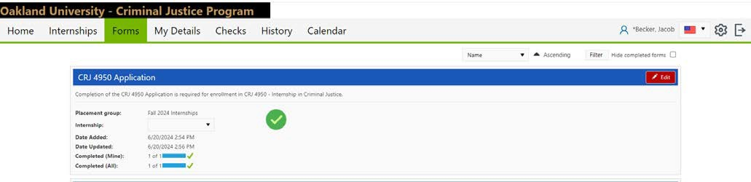

1 Remember that this guide is based on a “fake” student created to build and test the Sonia Online system for the CRJ program, so these dates are just placeholders for the purposes of this Guide.

My Details Tab
You can safely ignore this tab – the Criminal Justice program at OU does not currently use it for anything, but Sonia Online requires that it be displayed.

Checks Tab
As mentioned earlier, checks are required tasks that you must do to successfully complete your internship. These include what we call “pre-placement” checks, three of which you must complete in sequence to be placed at an internship site. In addition to these, you will also have three “post-placement” checks to complete once you are assigned to an internship site. Two of these six checks will be automatically satisfied when you complete and submit a form on Sonia Online: your CRJ 4950 application and your site evaluation. The other four checks require you to update their status when you have finished the related task(s): reviewing the internship manual, uploading your current resume, submitting your field placement contract, and submitting a field agency safety review.²

At the top of the ‘Checks’ tab you will see a summary list of all the checks that are currently assigned to you, and their status. The first three checks in the list below will be assigned to you as soon as you join the placement group (the “pre-placement” checks), while the last three will only appear once you have been placed at an internship site (the “post-placement” checks). On this summary list:

    - Clicking the name of a particular check will take you to that check’s detailed information lower down the page.
    - The value of a check reflects if you have completed all the tasks a student must do associated with the check.
    - The status of a check reflects if all the necessary tasks associated with it have been completed, whether assigned to a student, a Field Supervisor, the Director of Field Services, or some other role. If a check is “cleared” it is completely finished.

NOTE: In the Criminal Justice program, checks are designed so that they only require students to complete a single task, and there are no other roles (e.g. the Director of Field Services) involved. This means that the “value” field and the “status” field should always correspond with each other. Checks will be either have values of “yes” and a status of “cleared,” or a blank value and a status of “not completed.” When a check is completed it turns from red to green in the summary list; it will also change color lower down the page in the detailed check listings.
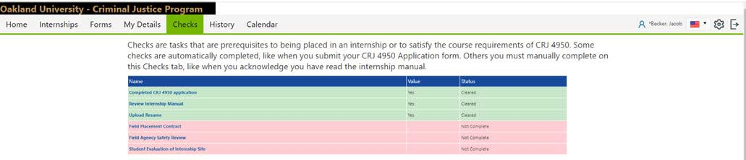
1
2
3

Lower down the page are boxes containing more detailed information on each of the checks listed in the summary, organized into “pre-“ and “post-placement” sections (again, you won’t see any “post-placement” checks until you have been placed in an internship). These boxes largely replicate the information reflected in the summary, particularly for the two checks that

2 These last two items will be completed in collaboration with your Field Supervisor.

are automatically completed when you submit your application form and site evaluation form, and may include more detailed information, like your placement group and internship site. For the other four checks, there are additional functions that students will use:

- After a student has completed a particular task, they will manually change the value of a check to “Yes,” indicating that they have satisfied that requirement (like reading the Internship Manual).
- Any time the value of a check is changed, the “Save” button at the bottom right must be clicked to update the Sonia Online system. Saving a check as complete (i.e. the value is “Yes”) will change the color of the box from red to green both here and in the summary list. If, for some reason, the value needs to be changed back to “No,” the box will revert to red as well.
- In cases where you must upload a document (like your resume), upload the relevant electronic file in the “Documents” box before changing the check value to “Yes” and saving. Uploading the document alone will not complete the check requirements. Sonia Online automatically changes the file name to “Student’s Name – Check Name.”
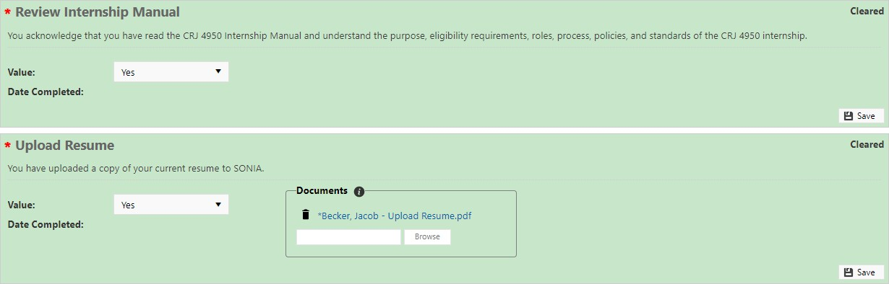
1
2
3

Completing checks is probably the most complicated thing you will need to do on Sonia Online, and students will be notified via email when they are expected to complete their next check. This email will contain detailed, step-by-step instructions on how to satisfy the requirements of that particular check, above and beyond the general overview offered here. When you clear a check, you will receive a confirmation email, with instructions for the next step in the process (if applicable). If there are ever any issues with your Sonia Online checks, please contact the Director of Field Services via email.

History Tab
This page lists placements that you have successfully completed in the past (so your current internship does not appear here). This tab is not particularly useful while you are currently in an internship, but once you have successfully finished you can find a “transcript” of your placement(s) here that includes information about the start/end dates, the site, your Field Supervisor, and hours completed.

Calendar Tab
Like the ‘My Details’ tab, you can safely ignore this tab – the Criminal Justice program at OU does not currently use it for anything, but Sonia Online requires that it be displayed.

Conclusion
This guide has been provided to Oakland University Criminal Justice students who are using Sonia as part of their internship course (CRJ 4950) to assist in the administration of field work placements (i.e. internships). You will hopefully have an easier time navigating the Sonia Online website now that you are more familiar with its important functions and interface, and will become more comfortable with the website as you actually use it. Keep in mind that the Criminal Justice program has designed our version of Sonia Online to be relatively basic, and we appreciate student feedback and suggestions for changes and improvements. If you ever run into any problems with the website, or have questions about how to use it for the purposes of your CRJ 4950 course, don’t hesitate to email the Director of Field Services and/or the instructor for your section of CRJ 4950.

